**Effect of Gemstones On Your Kundali**

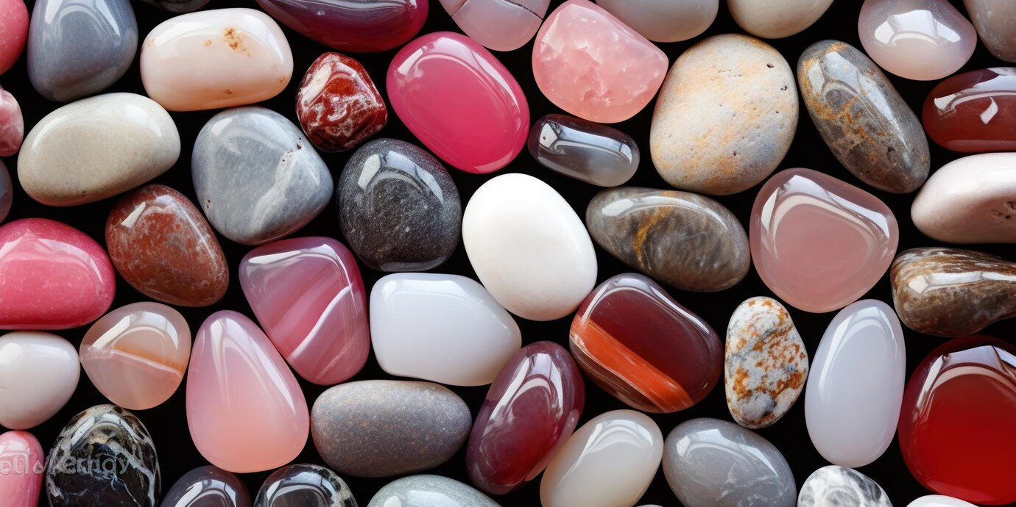

Gemstones or Vedic gemstones are mineral precious stones that have mysterious properties that influence any person or thing who interacts with them. According to the logical perspective, 9 regular and Vedic jewels influence the psyche, heart, and whole body of the person. The principal strength of gemstones lies in the tones they radiate. Albeit present-day science has neglected to perceive the enchanted abilities of gemstones, they are generally used to recuperate physical and profound afflictions. Various pearls have various characteristics; What makes a gemstone one-of-a-kind, alluring, and beguiling is its tone, cut, straightforwardness, and exuberance.

**Why Wear Gemstones?**

Gemstones are 9 of them. The Nav Ratnas address the 9 celestial planets alluded to in antiquated Vedic texts as the keys to neutralizing negative karmic powers and mending the psyche and body.

**Gemstones and Planets**

Gemstones and planets are connected. Vedic sages saw very well the impacts of planets on the psyche and body. Solid planets draw in certain energies though frail planets draw in difficulties and obstructions. Thus, Jyotish Shastra gives an understanding of concentrating on the planetary situations in your horoscope and prescribes the utilization of strong gemstones to upgrade the force of benefic planets and decrease the impacts of foreboding planets.

Each diamond is related to a planet. The gemstone is worn on the body to reinforce its planet or lessen the evil impacts of a frail planet. We should analyze the nine planets and their gemstones.

For comprehensive mending, strengthening, and achievement - pick a blend of Rudraksha with gemstone.

Chirag Daruwalla's spearheading disclosure of the mix of holy Rudraksha with gemstones is a logical treatment plan after a careful investigation of Rudraksha from the Upanishads and Puranas. Chirag Daruwalla dedicated 15 years to exploring the 'specific impacts' of different blends of hallowed Rudraksha dabs and Vedic gemstones on individual chakras. These pearls come in assortments from 1 Mukhi to 21 Mukhi. Each Mukhi has an answer for an alternate issue you face.

The Nav Ratnas address the 9 prophetic planets alluded to in antiquated Vedic texts as the keys to checking negative karmic powers and mending the psyche and body. Deductively, gemstones are mineral precious stones that can recuperate. At the point when the sun's beams go through the body they transmit bountiful infinite beams which are consumed by the 7 chakras of the body. They invigorate the chakras and eliminate negative energy.

Rudraksha and gemstones are joined in a one-of-a-kind string design and worn on unambiguous pieces of the body to open or adjust the chakras to achieve extraordinary impacts. This particular technique for wearing is not entirely set in stone as per the profound state of being of an individual and the issues faced by him. It is encouraged to wear a strategy and mix that guarantees 100 percent bring about opening or adjusting the chakras.

An ensured senior specialist gives coordinated guidance where an individual's concerns or concerns are examined and balanced to figure out the underlying driver of the issues. Yoga is suggested, which assists with opening or adjusting and reinforces impacted chakras. As per the astounding tributes shared by clients from varying backgrounds, this treatment has demonstrated to be an enormous outcome in the fields of vocation, and business. Connections, relational associations, and schooling.

**Benefits of Wearing Gemstones**

Gemstones were said by old sages to be fit for eliminating the adverse consequences of the planets and improving constructive outcomes. The varieties and vibrations of explicit gemstones relate straightforwardly to the tones and vibrations of the different chakras.

By wearing jewels that touch the skin specifically fingers, we increment the transmission of the grandiose variety of beams radiated by the planets. Which are dense by the jewels and course through the body and consequently enable explicit chakras. The Chakras are administered by the Divine beings and planets and when they get authority; One gets strength, boldness, backing, karma, and favors from divine powers to make progress.

The extraordinary properties of 9 regular and Vedic pearls make them considerably more important and useful and they contribute altogether in relieving sicknesses. The body requires beams of each of the 7 tones: red, orange, yellow, green, blue, indigo, and violet. Each shaded beam is associated with at least one chakra. Air, the etheric body or bio-attractive layer, is an inconspicuous energy field that encompasses the actual body. With the variety beam coordinated towards a specific chakra, one can mend the separate regions and organs generally. [**Talk to astrologers**](https://bejandaruwalla.com/pages/astrology-consultation-online) to find out which gemstone you should wear.

**Effect of Gemstones On Your Kundali**

**Yellow Sapphire/**[**Pukhraj**](https://bejandaruwalla.com/collections/gemstones/products/pukhraj-yellow-sapphire-jupiter-showers-favour)**:** Pukhraj enhances spiritual personality, communication skills, goal achievement, promotion, and desired abundance. Pukhraj cures insomnia and thyroid problems as it strengthens the Throat Chakra.

**Blue Sapphire/Neelam:** Neelam enhances intuition, dispels illusions, strengthens decision-making abilities, and helps you attain spiritual enlightenment. Neelam heals headaches and sinuses as it empowers the third eye chakra.

**Coral:** Coral gives emotional and physical strength as well as stability on a personal and professional level. Coral cures piles and bone-related problems as it provides strength to the Muladhara (root) chakra.

**Ruby/Manik:** Ruby gives power, and wealth and preserves your health.

**Pearl/Moti:** Pearl calms your mind, brings courage against all odds, and instills harmony in relationships. Moti heals the sexual organs that are controlled by the sacral chakra.

**Emerald/Panna:** Panna helps in fulfilling your desires, makes you compassionate, and strengthens your spiritual side. Panna heals the heart and lower lungs which are regulated by the heart chakra.

**Cat's Eye:** Cat's Eye is best for abstract thinking, self-discipline, perseverance, patience, a shield against negative forces, and ultimately enlightenment. Cat's Eye cures diseases related to bones as it acts on Muladhara Chakra.

**Gomed:** Gomed attracts fortune, power, and divine blessings. Gomed heals nervous disorders as it regulates the Crown Chakra.

**Diamond:** Being one of the most precious gemstones, Diamond bestows the wearer with wealth, successful married life, and compassion. Diamond cures diabetes and blood pressure as it controls the heart cycle.

**Everything Need to Know About Gemstone Recommendation**

Pearls are lovely gifts from nature; His way of thinking can take care of any issue. Various gemstones enjoy various benefits and are utilized for various purposes. Every gemstone has its profound properties. [Gemstone recommendation by date of birth](https://www.chiragdaruwalla.com/astrology-services/gemstone-recommendation-by-date-of-birth/) assists with tackling your concern. Nearly everybody deals with issues throughout everyday life. Issues fluctuate from one individual to another. Some have vocational issues, some have marriage issues, and some have medical conditions however everybody has issues.

At the point when a planet is in some unacceptable position then it makes a few foreboding impacts. Be that as it may, when at least two planets are ominous, their unpropitious impacts are more prominent. There are numerous ways of diminishing the ominous impacts of planets in the horoscope, yet it is viewed as more compelling to wear gemstones. By wearing gemstones numerous issues disappear.

It would be better if you picked a [**gemstone recommendation**](https://bejandaruwalla.com/pages/lucky-gemstones-recommendation) before purchasing any gemstone. Astrologers can assist us with knowing your birthstone, your fortunate gemstone, your reasonable gemstone, and that's only the tip of the iceberg. A few gemstones are not reasonable for everybody, by wearing an appropriate gemstone you can have everything. By wearing some unacceptable gemstone you can lose everything.