**Expert Fencing Solutions in Langley and Vancouver: A Comprehensive Guide**

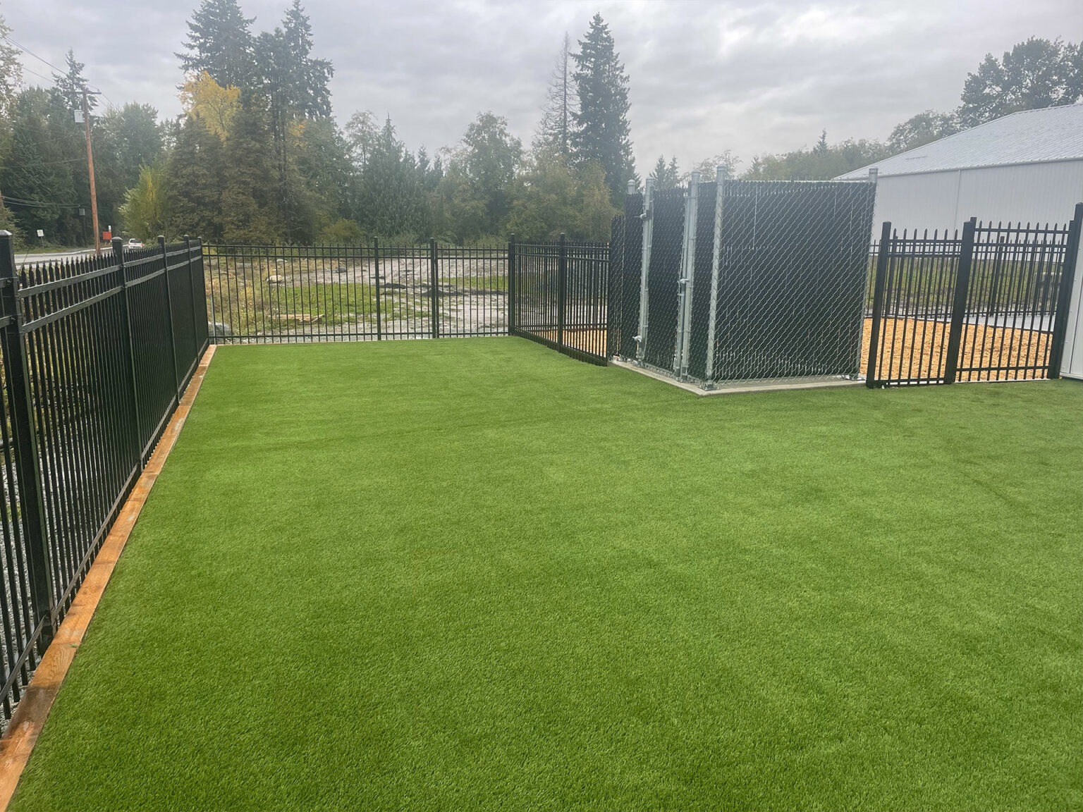

When it comes to enhancing the security, privacy, and aesthetic appeal of your property, professional fencing solutions are essential. In Langley and Vancouver,[**expert fence contractors**](https://www.abbyfencecontracting.ca/) provide a variety of services tailored to meet the specific needs of homeowners, businesses, and property managers.

**Here’s an in-depth look at the key aspects of fencing and how professionals in these areas can help.**

**Types of Fencing Installation Services Available**

**1. Custom Fencing Design & Installation**  
  
Professional fence contractors offer custom fencing options, designing fences that suit your property’s style and purpose. Whether you're looking for a classic wood fence, a durable vinyl fence, or a stylish ornamental metal fence, experts provide tailored solutions. They ensure proper installation, enhancing the fence's durability and appearance.

**2. Fence Repair & Maintenance**  
  
Over time, fences can suffer from wear and tear due to weather conditions or regular use. Expert contractors offer repair services to fix damaged sections, replace broken parts, and restore your fence’s functionality. They also provide regular maintenance, such as cleaning, staining, and sealing, to extend the lifespan of your fence and keep it looking great.

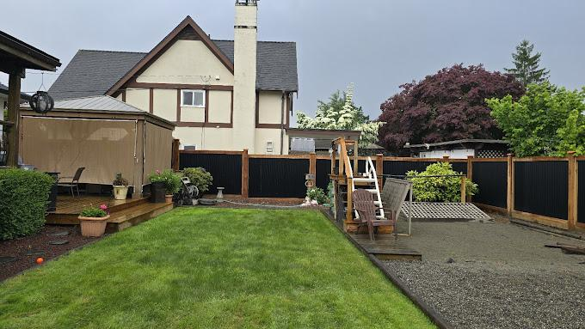

**3. Gates & Entry Solutions**  
  
In addition to fences, [**professional fence contractors in Langley**](https://www.abbyfencecontracting.ca/) and Vancouver also specialize in installing gates and entry solutions. Whether you need a decorative garden gate, a secure driveway gate, or an automated entry system, they provide a range of options to match your needs and preferences.

**4. Security Fencing**  
  
If security is your top priority, professional contractors offer specialized security fences, including options like[**chain-link fences**](https://www.abbyfencecontracting.ca/fencing/chainlink-fencing/) with barbed wire, ornamental metal fences with locking mechanisms, and privacy fences designed to deter intruders. These fences are built with strength and reliability in mind, providing peace of mind for your property.

**Why Choose Professional Fence Contractors?**

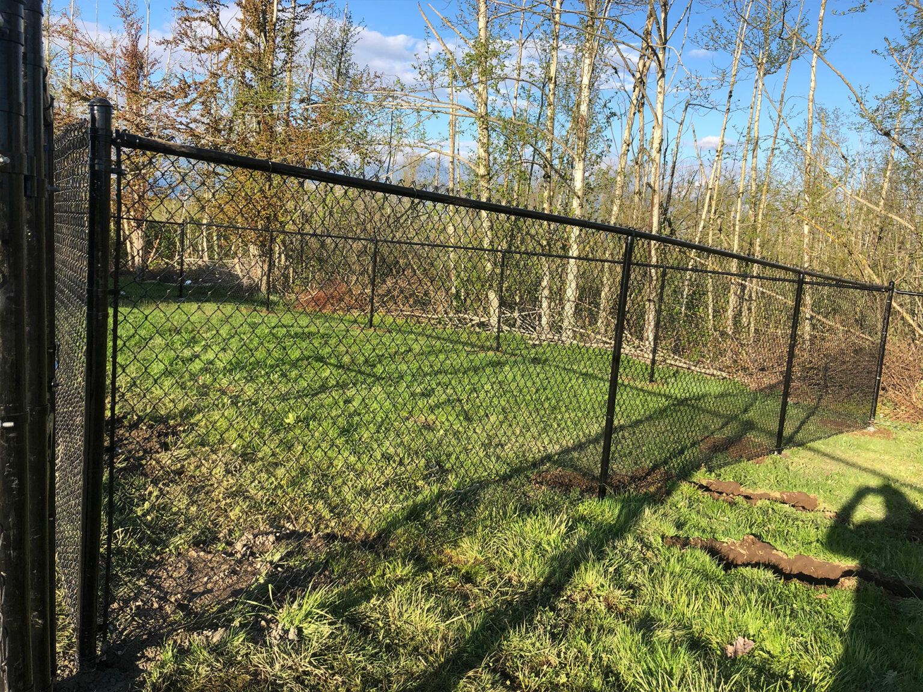

**1. Expertise and Experience**  
  
Professional contractors bring years of experience to the table. They understand local building codes, the best materials to use for various applications, and the techniques that ensure a fence is installed properly and lasts for years.

**2. Customization Options**  
  
Every property is different, and professional contractors understand the importance of creating a fence that complements your home or business. They work with you to design a fence that fits your specific needs, whether for privacy, security, or aesthetics.

**3. Quality Materials**  
  
Working with a professional contractor ensures you get access to high-quality materials that are built to last. Whether you choose wood,[**vinyl fencing**](https://www.abbyfencecontracting.ca/fencing/vinyl-fencing/), chain-link, or metal, you can trust that the materials used will be durable and weather-resistant.

**4. Efficient Installation**  
  
Experienced contractors know how to complete the job efficiently and correctly. They handle everything from preparing the ground to securing the posts and panels, ensuring that your fence is installed quickly without compromising on quality.

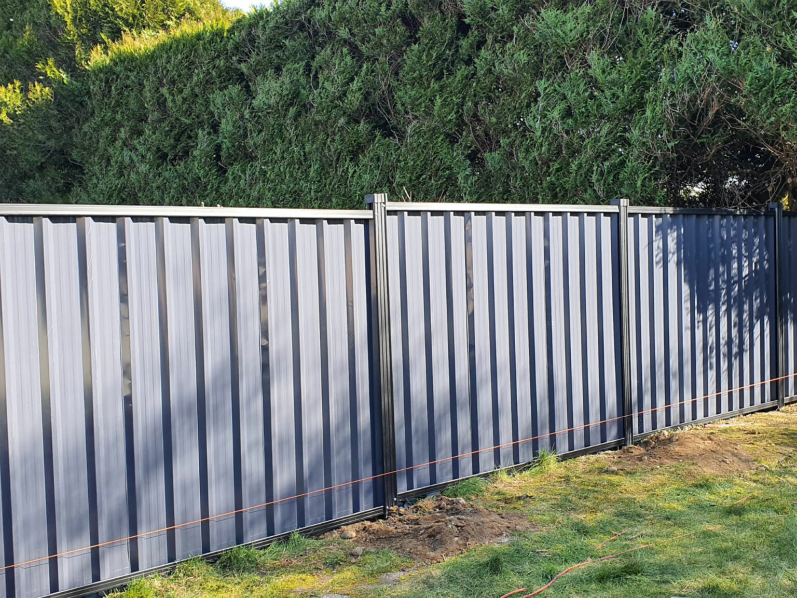

**Conclusion**

When it comes to fencing solutions in Langley and Vancouver, choosing a professional contractor offers numerous benefits, from expert design and installation to ongoing maintenance & repairs. Whether you're looking for privacy, security, or an [**ornamental fencing**](https://www.abbyfencecontracting.ca/fencing/ornamental-fencing/) feature for your property, experienced fence contractors can provide a solution tailored to your needs. With their knowledge, expertise, and attention to detail, your fence will not only add value to your property but also ensure lasting durability and appeal.

For more information or to get started on your fencing project, reach out to experienced professionals in your area to discuss your needs and request a free quote.