**Tips Follow You Will Enjoy Love Marriage In Arranged Marriage**

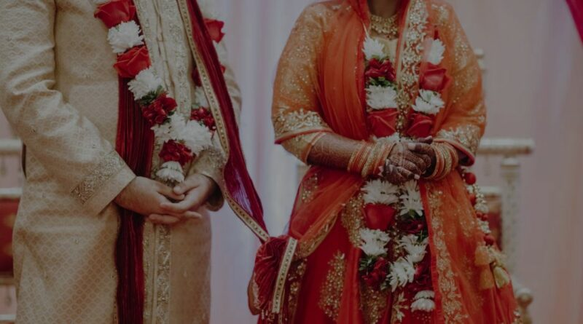

Arranged marriage or love marriage, what is better? The answer to this question may differ according to each person. In India, arranged marriage is more encouraged by explaining its benefits. A person either marries someone he loves or someone his family has chosen. Arranged marriage is quite common in India. Every other person in our society, especially women, is in favor of arranged marriages.

According to [Love marriage astrology](https://bejandaruwalla.com/pages/love-marriage-problem-astrologer), parents think that arranged marriages are more successful. Even though you get married, it is very difficult to get out of the troubles that follow. It’s natural to feel uncomfortable being with someone you don’t know well. However, with time you start understanding this relationship and your partner.

According to Marriage Prediction, if you are recently married or about to get married, these tips can help you find love in an arranged marriage too. Communication is an important part of strengthening and growing every relationship. The more you talk to each other, the better you will know and understand each other.

Apart from talking, it is also important to know about each other’s habits, likes and dislikes, and hobbies. With this, you will be able to get all the necessary information about them. You will also be able to share your habits, likes, and dislikes with them.

**Show Interest in Each Other**

If you want to step into your wife’s little world, try connecting with her. Show interest in things related to them. If you are curious to know about each other, then even in an arranged marriage both of you will be able to learn new things about each other. If you do not show interest in your partner, your relationship will become dull and you will not be able to find love in your marriage.

**Do not Complain**

Responsibilities and expectations are higher in arranged marriages. There is more pressure on both partners to manage the relationship. Your partner doesn’t need to share all your likes and dislikes. There may also be a difference between his family’s values and yours.

You may have to learn a lot of new things, but don’t worry about all this and start complaining. Harmony is very important in an arranged marriage. You should talk to your partner about this. Tell them what things are worrying you and how they can be improved.

**Create New Paths**

It is important to create new paths in the relationship after an arranged marriage. How do you want to move forward with your life? Make yourself comfortable with your partner and let your partner be comfortable too. If you are a part of an arranged marriage then this is a better step.

**Magic of Love**

According to Love Marriage Prediction by date of birth, love is an important part of any relationship which reduces the distance between you two. Everyone doesn’t need to fall in love at first sight. It can take time for everything to settle down in an arranged marriage. Slowly you will start loving each other.

Give your partner time to understand your feelings and think about how you can get their love back. The most important thing is that during this time you should be patient and not get discouraged.

**Time is also Important**

In a love marriage, you have already met each other and know each other, but in an arranged marriage, both of you are unknown to each other. If you are not giving time to your partner then this task becomes even more difficult. To know them, it is important to talk and give time to each other to talk. Therefore, along with spending time with family, also take time out for your partner. Strengthen your relationship during this time. If you want to know information about love marriage or arranged marriage then you can get information by [talk to astrologers](https://bejandaruwalla.com/pages/astrology-consultation-online).

In such a situation, it is important to consult your partner before making any decision. This will increase their respect for you and also your self-esteem, which is necessary for strong bonding.