**Kundali Matching & Marriage Horoscope by Date of Birth**

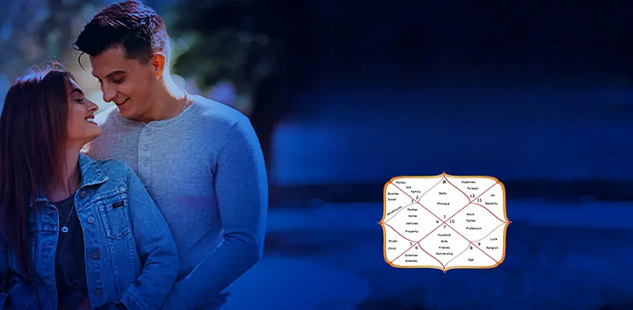

Matchmaking for a [**Marriage Horoscope by Date of Birth**](https://bejandaruwalla.com/pages/marriage-prediction) is an ancient practice of checking the horoscope of the prospective bride and groom. From this, the compatibility of two persons can be understood. The purpose of this article is to make you understand the importance of matchmaking for marriage.

**The Role of Kundali Matching Before Marriage**

According to [Kundli Match Making](https://bejandaruwalla.com/pages/kundali-matching-match-making), Kundli matching is the best way to find the right partner for you. Vedic astrology has given us horoscope matching as a boon, through which we can understand the nature and characteristics of our partner.

**How does Kundli Matching work?**

Both you and your partner will be of a particular moon sign. Your entire life can be predicted based on that Moon sign and your happiness and challenges can be analyzed based on that.

Horoscope matching is a very deep science, which analyzes how two different energies work together throughout life. By analyzing both the horoscopes we will have a road map through which we will be able to be aware of all the upcoming events in our married life. By keeping in mind some parameters like Nakshatra, inauspicious nature, auspicious nature of planets, and lord of the seventh house, we can know how the journey of married life will be.

**Different Parameters in Kundali Matching**

There are three parameters, that are used while matching the horoscopes (Kundli) of two individuals, which are – Guna Matching, Manglik Dosha, and the strength of Navamsa Kundli (Divisional Chart 9-D9).

**Guna Matching**: Guna refers to the characteristics of the bride and groom based on the Moon sign in their horoscope. This attribute matching is a specific process known as Ashtakoot matching, where all the calculations are done. Ashtakoot symbolizes the mixture of eight important parameters including the bride and groom.

Based on this Astkoot matching you will have some points and points will be distributed to everyone based on their order.

**Otherwise**: Nowadays both boys and girls need to work and be career oriented. Sometimes, it happens that due to their individual careers, the couple does not get a chance to spend time with each other, which would help in situations leading to an unsuccessful marriage. In this way, Varna matching will give you the best groom for marriage. With Varna Matching, you will be able to find your ideal partner and also have a stable and happy married life.

**Vashya**: Mutual attraction and different likes and dislikes between the couple are all part of the process. If you like to spend time with your partner, this will happen only if the Vashya matches with your spouse's horoscope. If you have good numbers in your Vashya Ashtakoot matching, there will be a beautiful mutual attraction between you and your partner.

**Tara or Dina**: If you and your partner have a favorable star or constellation in your horoscope, your married life will go smoothly.

**Yoni**: A stable sex life plays an important role in a marriage, And if there is no satisfaction then ultimately the decision to divorce will come in the relationship. If you have a good number in your Yoni matching then your sex life will be good in your married life.

**Graha Maitri**: If you score good marks in Graha Maitri, it will give you complete mental inclination with similar likes and dislikes, and will also maintain harmony between you and your partner.

**Gana**: To marry a person who is different from your community, Gana matching has to be calculated. If Gana Maitri's numbers are good in the horoscope matching then your life partner will get along very well with you and your family.

**Bhakoot**: Bhakoot Milan will bring an emotional bond between you and your partner, which is essential to maintaining a good relationship throughout your lifetime.

**Nadi**: Children play a very important role in marital life. The child will strengthen the bond between you and your partner. The type of child you will have will be analyzed through pulse matching.

**Manglik Dosh**: When there is Manglik Dosh in the horoscope

If Mars is situated in the 12th, 1st, 4th, 7th, and 8th house from natal Venus, Moon, and Lagna, then Manglik Dosha will occur in your birth chart.

If Mars is situated in all the houses from Lagna, Moon, and Venus, it gives you high Manglik Dosh.

If Mars is situated in the 12th, 1st, 4th, 7th, and 8th house by any of the three parameters mentioned then the following Mangal Dosha will be present. There will be some problems in marital life due to Mangal Dosh, but you can improve the situation by taking some measures related to Manglik Dosh.

If there is Manglik Dosh in your horoscope then you should take remedies related to planet Mars. This will provide real true insight into what Martian energy wants you to do. Remedies related to the planet will keep you in tune with the energy of the planet, which will make your life easier even in difficult situations.

**Navamsa Horoscope (Mandala Chart 9-D9)**

The ninth part of the ascendant is called Navamsha. In Vedic astrology, Navamsha defines your duty (dharma) that you have to follow to achieve your goal. Marriage is one of the most important religions and important rites of passage in Vedic culture.

If your seventh house is strong and the seventh lord is in a good house in the navansh horoscope then your married life will be happy.

If the seventh lord is afflicted in the main horoscope but is in a good position in the ninth house, then your married life will be good. To get good results from planetary positions you just need to take some measures.

**The Imperative need of Kundali Matching**

Nowadays people do not hesitate to be in a live-in relationship with their future partner to understand their partner before marriage. If the idea is successfully executed, the couple moves forward with joy and if not, they go their separate ways to look for another partner. However, sometimes even after being in a live-in relationship, some marriages end in divorce and the partners separate from each other.

If you have prepared yourself for a lifelong journey with your partner with whom you have a good connection, then you can name your relationship as 'marriage'. Before marriage, you must have done many preparations and every work has to be done meticulously so that the wedding day becomes the best day of your life, which you will remember throughout your life.

However, the real story will start after the wedding and the journey of your married life will give you bittersweet memories that both you and your partner will share. Sometimes if you start hiding something from your partner, or feel lonely even in the presence of your partner, you may feel immense guilt.

According to Marriage Astrology, therefore, before marriage, start preparing by matching your horoscope with that of your partner, so that you can know in what condition your life partner is and how it will be for you and why. Horoscope matching will truly serve as a road map for the long life journey that you are going to take with your special 'one'.