**Astrology Work In Marriage Prediction By Date Of Birth**

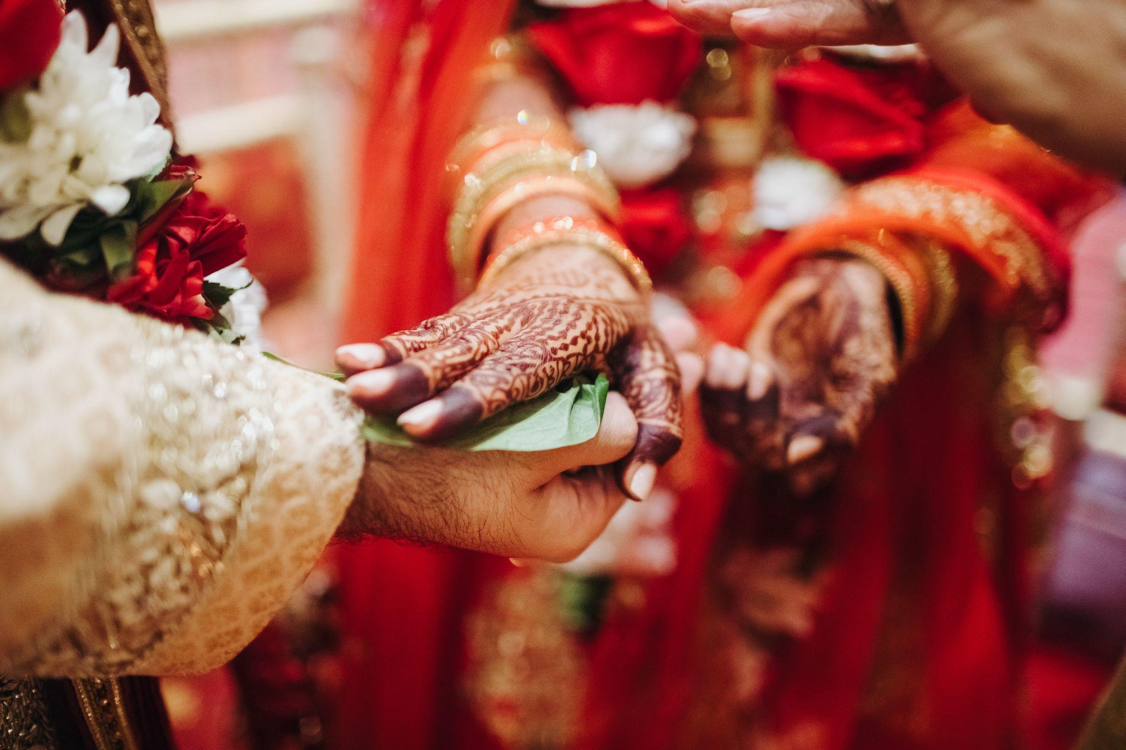

Marriage is an extraordinary occasion that causes a huge change in the existence excursion of every individual. A long-lasting responsibility between two accomplices needs to share their lives. Many individuals guarantee that they have better standards of getting hitched because it decides one's prosperity, bliss, and other fundamental everyday issues.

In any case, you might feel somewhat wary about your marriage forecast: when will you get hitched, what is the ideal opportunity to choose, and for what reason in all actuality do individuals get hitched at an early age? You can find this large number of solutions through [marriage prediction by date of birth](https://bejandaruwalla.com/pages/marriage-prediction).

**How Marriage Prediction Works**

For an effective relationship, the two accomplices should have attractiveness and actual fascination. Soothsaying helps in knowing the similarities and helps in working on the wedded life between accomplices. This will help you foresee or know whether you will have an organized or loving marriage.

[Marriage prediction astrology](https://www.chiragdaruwalla.com/astrology-services/marriage-prediction-by-date-of-birth/) will educate you regarding your soul mate. If you have an accomplice and are dealing with issues in orchestrating your marriage, your marriage horoscope will explain to you why your marriage is getting deferred.

It allows you to figure out the adverse consequence of planets and Dashas on the couple's marriage and future. By utilizing marriage soothsaying, you can realize your accomplice's vocation progress and headway from his/her horoscope.

Logical crystal gazing marriage expectation will distinguish a subsequent marriage happening because of a Dosha in the seventh house. This variable is impacted by Venus and Jupiter. In light of your date of birth, a soothsayer can investigate your marriage horoscope and foresee everything connected with your marriage.

**Marriage Prediction by date of birth**

According to marriage astrology prediction, the topic of the seventh house out of the twelve places of your introduction to the world diagram is marriage. Venus is the planet that works with an individual's marriage. The fortunate planets in the horoscope surprisingly are Venus, Mercury, Moon, and Jupiter. Though Saturn, Mars, Sun, Ketu, and Rahu are ominous planets. Fortunate individuals demonstrate early marriage, while unfortunate individuals energize deferring marriage.

A stargazer predicts marriage given the date of birth. He analyzes the seventh house, which demonstrates your entire life associations and manages all marriage viewpoints. He will perceive that individuals between 18 to 23 years old can get hitched when Mercury or Moon is available in the seventh place of their horoscope. The horoscope of individuals who matured between 24 to 26 years is viewed as great just when Jupiter is in the seventh house. If Sun is in the seventh house, you will confront difficulties and defers in your marriage.

Subsequently, Mars is set in the seventh house which is called Manglik, which will create serious setbacks for marriage. If Saturn angles the seventh house, getting hitched for somewhere around 35 years is testing.

Then a stargazer moves to the second house to look at the family development, collection of riches, and youngsters, which are fundamental for a wedded couple. The following house to take a gander at is the fourth house for family joy and a superior life. After this, the fifth house predicts a love marriage. Finally, the eighth house is seen for sexual life and relations with parents-in-law and is seen for extramarital undertakings in the relationship.

So these are the significant elements to be seen from the horoscope and the specialized things that a stargazer takes a gander at to foresee your marriage in light of your introduction to the Kundali.

**Important Role Of Venus In Marriage Prediction**

Here we have previously discovered that the planet Venus addresses concordance, love, and warmth. Assuming that the place of this planet is better in your introduction to the world outline and is available in the best house, then your wedded life will be unbelievable and merry. During horoscope coordination, marriage can be anticipated by checking out at the place of the date of birth.

Having this planet in support of yourself in your horoscope is an enormous benefit as it wipes out the possibilities of separation and partition from your accomplice's life. If this planet affects your introduction to the Kundali, it is hard for you to get hitched, or it might cause issues in your wedded life.

**Prediction Of Marriage Time**

It means a lot to carry on with a blissful and prosperous life in the wake of getting hitched. Subsequently, after the horoscope matching for marriage is finished, the principal perspective is to know the ideal opportunity and date to get hitched. For this reason, you can utilize a marriage expectation to know the favorable date and time to orchestrate your wedding function.

Be that as it may, in Vedic Astrology's expectation, the impact of the planet due to dasha and antar dasha is felt on the time and date of your marriage. Dasha is the period that starts with the development of planets in an individual's horoscope and closures following quite a while. Then again, Antar Dasha begins from the very start till the finish of this period.

Additionally consider these periods alongside different components like travel outlines, dasha yogas, and so forth while computing your wedding dates. This will allow you effectively to picture the particular date to orchestrate your wedding or let you know regardless of whether it will happen. Consequently, soothsaying has many advantages while foreseeing one's marriage. It likewise decides the position and doshas of every planet to keep away from issues in your marriage.

**Conclusion**

Marriage astrology prediction is a science that helps you predict your marriage. It is also necessary to find out your birth chart. You can [talk to astrologers](https://bejandaruwalla.com/pages/astrology-consultation-online) for marriage astrology services. Take help from them to get accurate zodiac predictions on your marriage.

The astrologer will take nitty gritty data about your introduction to the world and attempt to coordinate your horoscope with your accomplice's horoscope utilizing the date of birth. This is to understand what sort of marriage you both will have. Be it an affection marriage or an organized marriage later on, you want to think about this multitude of expectations and confirm the celestial marriage viewpoint in an individual's life to effectively get hitched.